Compute Cross-Correlation of the Height of Left Paw And Firing Rate of Each Unit

File: cross_correlation_left_paw.m

Input :

background picture bg.jpg

.csv file from DLC (‘press1’ should be renamed to ‘press01’ to be sorted by filename)

r from RTarrayAll.mat

Cross-correlation_Unitx.png

Correlation with left paw.png

Output:

Fig directory:

trajectory.png

1. Training a good DLC to extract the position of left paw

When the paw is in the air, it is hard for DLC to recognize it. A better DLC model is still in need.

From the *filtered.csv file, extract the x & y of left paw and the possibility that DLC recognize them successfully.

Videos with following features are selected:

1. Videos start with left paw on the ground
2. Before pressing, more than 30 points of left paw (60 in total) are recognized by DLC
3. When pressing, the left paw should be on the lever

The missing points (possibility<0.95) are linearly interpolated to the trajectory.

Then, the trajectory of these videos is plotted on the background picture.

The y pixels in the picture are not the real height of left paw. The height of left paw $h_{paw}$ is defined as:

$$h_{paw}(y_{paw})={(y}_{ground}- y_{paw})/(y_{ground}-y_{lever})$$

1. Get press time information

The code is from ExtractEventFrameSignalVideo.m

The press time is equal to the timestamp of frame #59 in the video.

1. Compute firing rate

I choose the bin width = 1ms for convenience.

firing_rate = smoothdata(firing_rate,'gaussian',50);

The smooth factor can be changed.

1. Compute cross correlation

Here we only consider the situation before press.

$$Cor\left(τ\right)= \int_{t_{pre}}^{0}{h_{paw}^{z}\left(t+τ\right)f^{z}\left(t\right)dt}$$

$$h_{paw}^{z}=\frac{h_{paw}-mean\left(h_{paw}\right)}{σ\left(h_{paw}\right)}$$

$$f^{z}=\frac{f-mean\left(f\right)}{σ\left(f\right)}$$

f is the firing rate of one unit.

This form is chosen because we can compare the correlation between different unit as well as get the specific $τ$ that generates maximum correlation.

In order to avoid the effect of holding lever, release, award and so on, we choose the time range (-1200ms, 0ms) to compute the $mean\left(f\right)$ and $σ\left(f\right)$.

1. Result

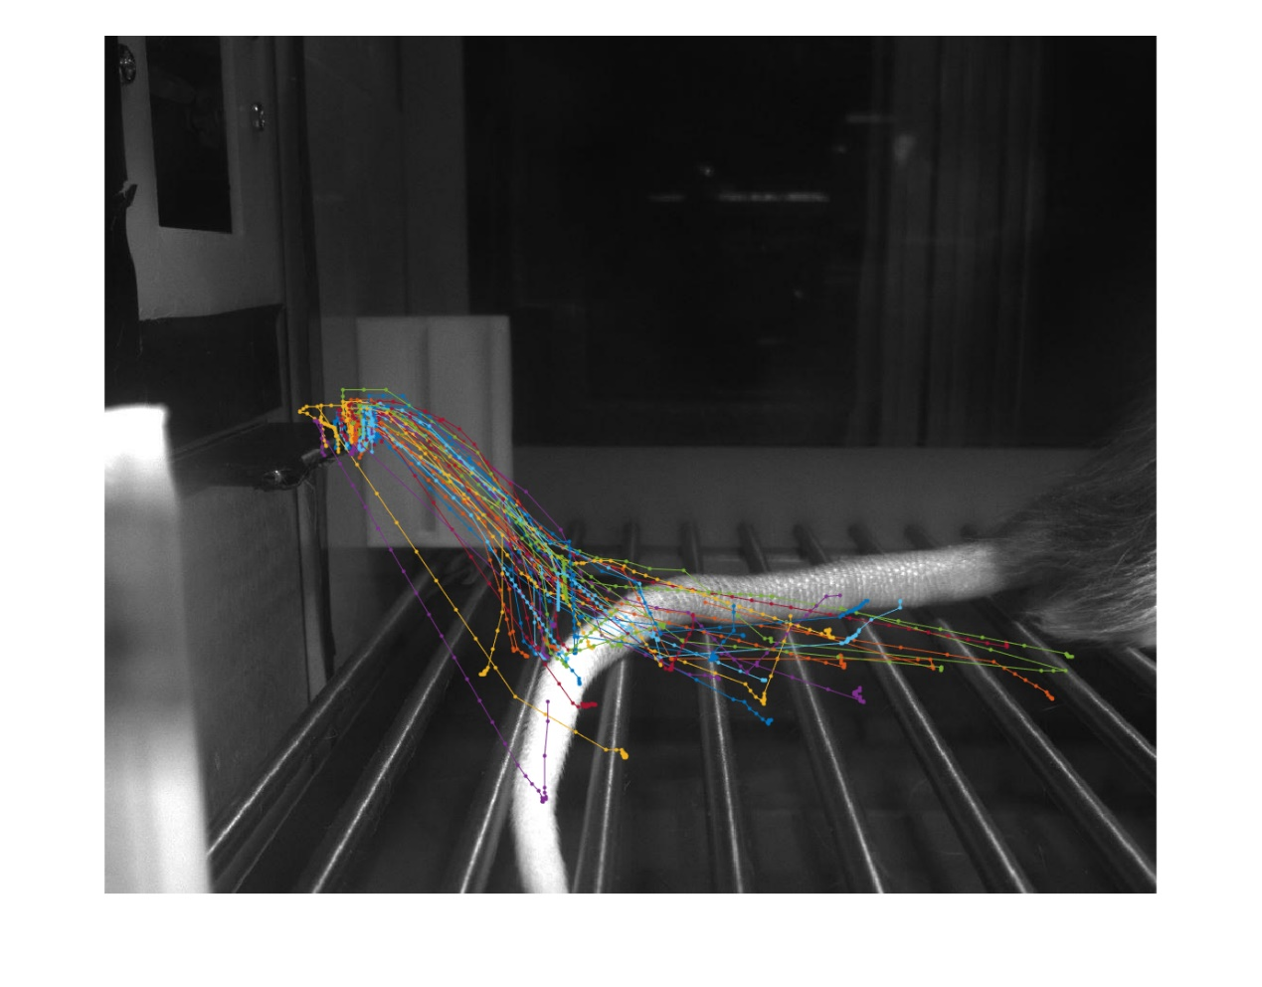 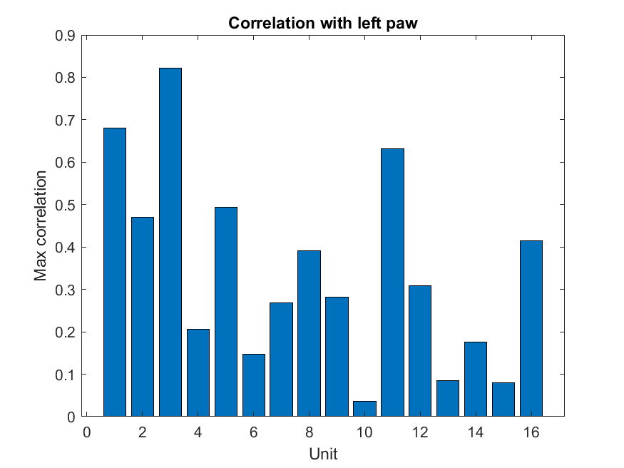

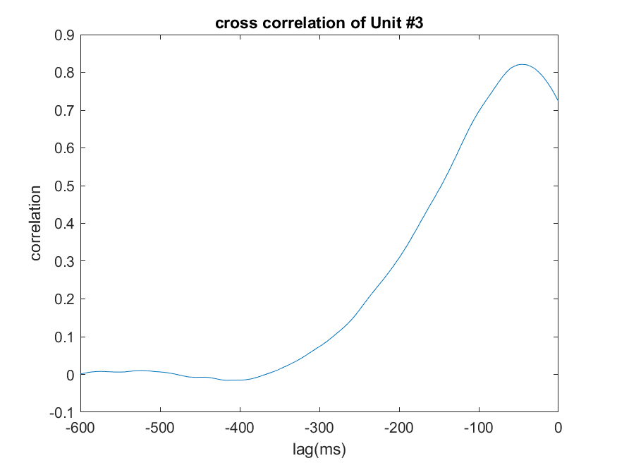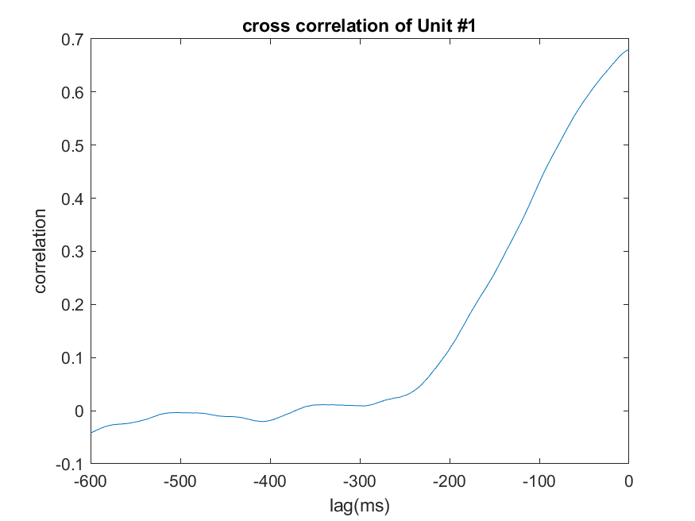

Unit 3 has maximum correlation with the height of left paw. The lag is about 50ms.

1. To improve

Now only 60 videos are used due to inefficiency of DLC. A better model should be trained.

A wider range of videos can be used (600ms before lever press now).